Chapter 6 Result and Discussion
This chapter reports what happened when the system was measured. It begins with the evaluation methodology that governs every number in it, then reports each phase in turn: retrieval, generation, the evidence ablation, the grounding failure and its remediation, and the accuracy experiment. It then analyses which design choices the evidence supports and which it does not, states the statistical properties that bound every result, compares against published work under an explicit caveat, and closes with what the system achieves and what it does not.
Three rules govern this chapter and are stated before any result. First, results are never pooled across phases: each phase ran on its own case set, under its own code state, with its own instrument, so every table states its own n and no number from one table is differenced against a number from another. Second, every difference carries a 95% confidence interval, and a difference whose interval includes zero is reported as not having cleared — including where the point estimate favours the design this project adopted. Third, negative and inconclusive results appear in the main text at the same weight as positive ones. Four results in particular must not be misread, and they are flagged where they appear: Phase 0’s Gate 2 on Recall@5 did not clear; Phase 21’s primary endpoint did not clear at either sample size; Phase 20’s BERTScore tier failed its own validity bar; and Phase 22 passed every automated criterion but adoption is not final.

6.1 Evaluation Methodology and Performance Evaluation

6.1.1 Pre-registration
Each evaluation phase wrote its decision rule into a committed document before any output existed to score. That document named the primary endpoint, the field it is computed on, the averaging convention, the statistical procedure, the direction that counts as success, and — in the later phases — the stop conditions and withhold triggers that would override a pass. The ordering is verifiable from the repository rather than asserted: the Gate A run plan was committed at 55e8bc08 on 2026-09-22 at 01:09:38 +0600, before a single report of the version it evaluates existed, and the Phase 23 plan at d55bd8b8 before any variant ran.
The discipline was honoured where it cost something, which is the only test of it that matters. In Phase 21 the primary endpoint failed to clear and no alternative metric was promoted to replace it, because the pre-registration forbade that in advance. In Phase 23 the selection rule was applied mechanically by a script rather than by judgement, and it selected the incumbent. In Phase 20 an entire tier was discarded for failing its validity check. One genuine pre-registration defect also occurred, and §6.5.6 records it rather than resolving it quietly.

6.1.2 Paired bootstrap, and why intervals rather than point estimates
Every comparison in this chapter is paired: the two arms are evaluated on the identical case set, so each case contributes a difference and the resampling is over those differences. Pairing cancels the shared case-level variance — the fact that some studies are simply harder than others — which would otherwise dominate any between-arm comparison at these sample sizes. The configuration is 2,000 resamples, seed 42, percentile method, and it is the same configuration throughout, carried forward from Phase 0 rather than re-chosen per phase.
Point estimates alone would be misleading here, and demonstrably so. Several differences in this chapter have point estimates that favour the adopted design while their intervals comfortably include zero; reporting the point estimate alone would convert “we cannot distinguish this from no effect” into an apparent finding. Phase 0 additionally used class-stratified resampling, because the Normal class is roughly 47% of this dataset and pooled resampling over such a distribution is deceptively favourable.

6.1.3 The frozen labeller as a single instrument
Every clinical-label number in Phases 20 through 23 comes from one unchanging instrument: the evaluation path running inside a frozen virtual environment, never the runtime adapter that serves the live consistency check. This is what makes statements about the instrument comparable across phases even though results are never pooled. The two runtimes were proven label-equivalent (§5.4.2), and uncertain labels are collapsed to positive following Miura et al. (2021) — a stated deviation from the labeller’s own weighted-F1 metric, recorded in the scoring code.

6.1.4 The leakage-safe test pool
The knowledge base is the training split only; generation is evaluated on test-split studies. The split is leakage-controlled at study level and by near-duplicate clustering with clusters as the atomic unit (§4.4.4), so a query case can retrieve neither itself nor its own near-duplicate. Purity was verified directly before any evaluation ran: the vector store’s actual indexed identifiers and the source embedding cache were each read and cross-referenced against the recorded test identifiers, confirming zero test-split overlap in either, with the collection’s own split metadata field explicitly distrusted because it is a hardcoded literal rather than a per-study value. The evaluation pool is the 477 test cases that have a frontal image, real findings and a real impression — the only two fields with genuine ground truth.

6.1.5 What each phase asked
Table 6.1: The evaluation phases, their questions, case sets and verdicts.
Source: 06_results/, one file per phase.
Phase | Question | n | Verdict
0 | Does BiomedCLIP retrieve clinically similar cases well enough to justify the architecture? | val split vs 2,462-study KB | BiomedCLIP adopted. Gate 1 passed; Gate 2 split — Recall@5 inconclusive; Gate 3 satisfied.
Gate B | What threshold values does the admission and projection gate need? | 600 studies (300 frontal, 300 lateral) | Three values selected; one rule later revised post-hoc.
20 | How good are the generated reports, measured three ways? | 460 completed of 477 | Tier 1 usable; Tier 2 invalid; Tier 3 the valid clinical instrument.
21 | Does full retrieved evidence beat voted labels alone? | 100 (three arms) and 477 (two arms) | The pre-registered primary endpoint DID NOT CLEAR at either n. Secondaries all cleared.
22 (diagnosis) | Why do impressions contradict their findings, copy neighbours and assert absent priors? | 477 | Four root causes confirmed; three independently sufficient.
22 (Gate A) | Does the v1.2 fix reduce ungrounded language without damaging accuracy? | 477 paired | PASS on all three gating criteria. ADOPTION NOT FINAL — a withhold trigger is open.
22 (post-hoc) | Is the improvement just shorter text? | 477 | No, refuted on four independent tests — but two findings argue against the fix.
23 | Does a larger model or a label checklist improve accuracy? | 150 dev cases × 4 variants | The winner was the incumbent. No variant beat it; Step 3 was not run.

6.2 Retrieval Results (Phase 0)
Phase 0 was the gate that justified the whole architecture: four encoders compared under an identical image-to-image retrieval protocol, with the knowledge base built from the training split and queried with the validation split, relevance defined by graded label overlap over the 18-class curated taxonomy.
Table 6.2: Phase 0 encoder bake-off: macro-averaged retrieval metrics.
Source: ml/outputs/evaluation/encoder_comparison_macro.csv, via 06_results/phase00_retrieval.md §1.1.
Encoder | MRR | R@1 | R@5 | R@10 | nDCG@10
biomedclip | 0.4238 | 0.2826 | 0.5875 | 0.7422 | 0.1745
clip_generic | 0.3091 | 0.1304 | 0.5227 | 0.6831 | 0.1140
densenet121 | 0.3511 | 0.1806 | 0.5127 | 0.6808 | 0.1324
random | 0.3237 | 0.1627 | 0.5155 | 0.6995 | 0.1021
One row deserves particular attention, because it decided the project’s central design question. DenseNet121 — the classifier P1/P2 specified as the core of the pipeline — reached a macro Recall@5 of 0.5127, below the random baseline’s 0.5155. ImageNet features, used zero-shot, carry no useful signal for retrieving clinically similar chest radiographs. That is the empirical basis on which classification was abandoned in favour of retrieval (§4.3.1).

6.2.1 The three pre-registered gates
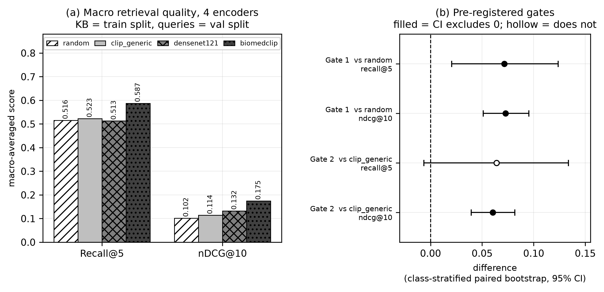
Figure 6.1: Phase 0 encoder bake-off with both pre-registered gates and their class-stratified paired bootstrap confidence intervals. Marker convention: a filled marker means the interval excludes zero; a hollow marker means it does not. The Gate 2 Recall@5 marker is hollow.
Source: thesis final report/04_figures/fig01_phase0_encoder_bakeoff.png, built from encoder_comparison_macro.csv and gate_decision_table.csv. Nothing was recomputed.
Table 6.3: The three pre-registered gates and their verdicts. n = val split queries against the 2,462-study training KB.
Source: ml/outputs/evaluation/gate_decision_table.csv, class-stratified paired bootstrap, 2,000 resamples.
Gate | Comparison | Metric | Δ | 95% CI | Excludes 0 | Verdict
1 | biomedclip − random | recall@5 | +0.0716 | [0.0204, 0.1236] | yes | PASS
1 | biomedclip − random | nDCG@10 | +0.0726 | [0.0510, 0.0952] | yes | PASS
2 | biomedclip − clip_generic | recall@5 | +0.0639 | [−0.0065, 0.1336] | no | INCONCLUSIVE
2 | biomedclip − clip_generic | nDCG@10 | +0.0604 | [0.0394, 0.0817] | yes | PASS
3 | wins concentrate on real findings | — | 11 of 15 real-finding classes | — | — | SATISFIED
Gate 2 did not pass cleanly, and this report does not present it as though it did. BiomedCLIP beats generic CLIP on nDCG@10 with the interval excluding zero, but the Recall@5 comparison is inconclusive at this sample size — the interval spans zero, containing values favouring either encoder. The likely reason is that Recall@5 is a coarse binary top-5 hit-or-miss signal while nDCG@10 uses the full graded ranking and therefore extracts more information from the same queries; but that is an explanation, not a rescue. The Recall@5 comparison against generic CLIP remains open.
Gate 3 was satisfied qualitatively: BiomedCLIP beat the random baseline on 11 of 15 clinically meaningful finding classes, with a pronounced advantage on Pleural Effusion (0.889 against 0.444–0.511 for the competing encoders). A weak spot on the heterogeneous Degenerative/Bone class is documented as a limitation rather than omitted.
The decision, stated at the strength the evidence supports: BiomedCLIP was adopted as the frozen encoder on Gate 1’s clean pass, Gate 2’s partial pass on nDCG@10, and clinically coherent per-class wins — reported honestly including the inconclusive comparison rather than rounded up to a clean sweep.

6.2.2 How good the relevance proxy itself is
Every Phase 0 number rests on a proxy: relevance defined by curated-label overlap rather than by clinical judgement. That proxy was itself validated, which is unusual and materially changes how the numbers should be read. 180 query–retrieved pairs (36 queries × top-5 BiomedCLIP neighbours, stratified across classes) were read and rated for genuine clinical relevance from the findings and impression text directly, not from label metadata.
The result: the proxy is 89% precise and 49% recall against hand-read judgement. When it says relevant, it is almost always right; it misses roughly half of genuinely relevant retrievals, because clinically related findings sometimes fall into different curated buckets. The proxy is therefore a conservative lower bound, and the Phase 0 metrics likely understate BiomedCLIP’s true clinical retrieval quality — which strengthens rather than weakens the case for adopting it.
A methodological note is recorded with it: an initial attempt to produce these ratings with an automated keyword-and-negation heuristic reached only 67% agreement with hand-read judgements on a calibration sample and was discarded in favour of reading all 180 pairs directly.

6.2.3 Gate B calibration, and a post-hoc revision
Table 6.4: Gate B threshold calibration. n = 300 per projection, from a 600-study set.
Source: ml/outputs/calibration/v1_1_gate_b_selected_values.csv; backend/app/core/config.py:364-403.
Setting | Value | Rule | Result | Status
MODALITY_THRESHOLD | 0.60 | False-negative budget 0.02, stated before results were read. | Frontal FNR 0.0000; 0.82 considered and declined. | pre-registered
PROJECTION_REJECT_THRESHOLD | 0.8695459 | Midpoint of the observed separation gap (lateral max 0.8484709, frontal min 0.8906209). | 300/300 lateral rejected, 0/300 frontal. | pre-registered, then superseded
PROJECTION_REJECT_THRESHOLD | 0.8500 | Just above the observed lateral maximum. | Re-verified on the same 600 studies: 300/300 lateral rejected, 0/300 frontal. | POST-HOC, revised 2026-08-19
RETRIEVAL_FLOOR | 0.8906208872795105 | 0th percentile of the frontal set — the only lower-tail percentile placing the boundary at the edge of the observed band rather than inside it. | 0 of 300 fall below it — the mechanism is UNEXERCISED. | pre-registered
The revision is stated here exactly as the source states it. The selection rule was changed after seeing a failing image: a genuine frontal chest radiograph from outside the dataset scored a top-1 similarity of 0.8582 and was rejected as a projection mismatch, sitting above every lateral in the calibration set and below the old midpoint — inside the empty gap the midpoint rule had placed the boundary in the middle of. The defence offered is that the calibration population was single-dataset, that no observation of any kind lies between 0.84847 and 0.89062, and that moving the boundary to the edge of what was observed removes an unmeasured margin rather than adding one. It remains an observed separation point, not a validated frontal/lateral boundary.

6.2.4 What Phase 0 does not establish
- It does not measure generation quality — that is §6.3.
- It does not establish that retrieval helps generation — that is §6.4, and its primary endpoint did not clear.
- The Recall@5 comparison against generic CLIP remains open.

6.3 Report Generation Results (Phase 20)
Phase 20 measured the v1.1 system — before the Phase 22 fix — on the test split, in three tiers: n-gram overlap, embedding similarity, and clinical labels. 460 of 477 eligible cases completed; 17 failed structurally.
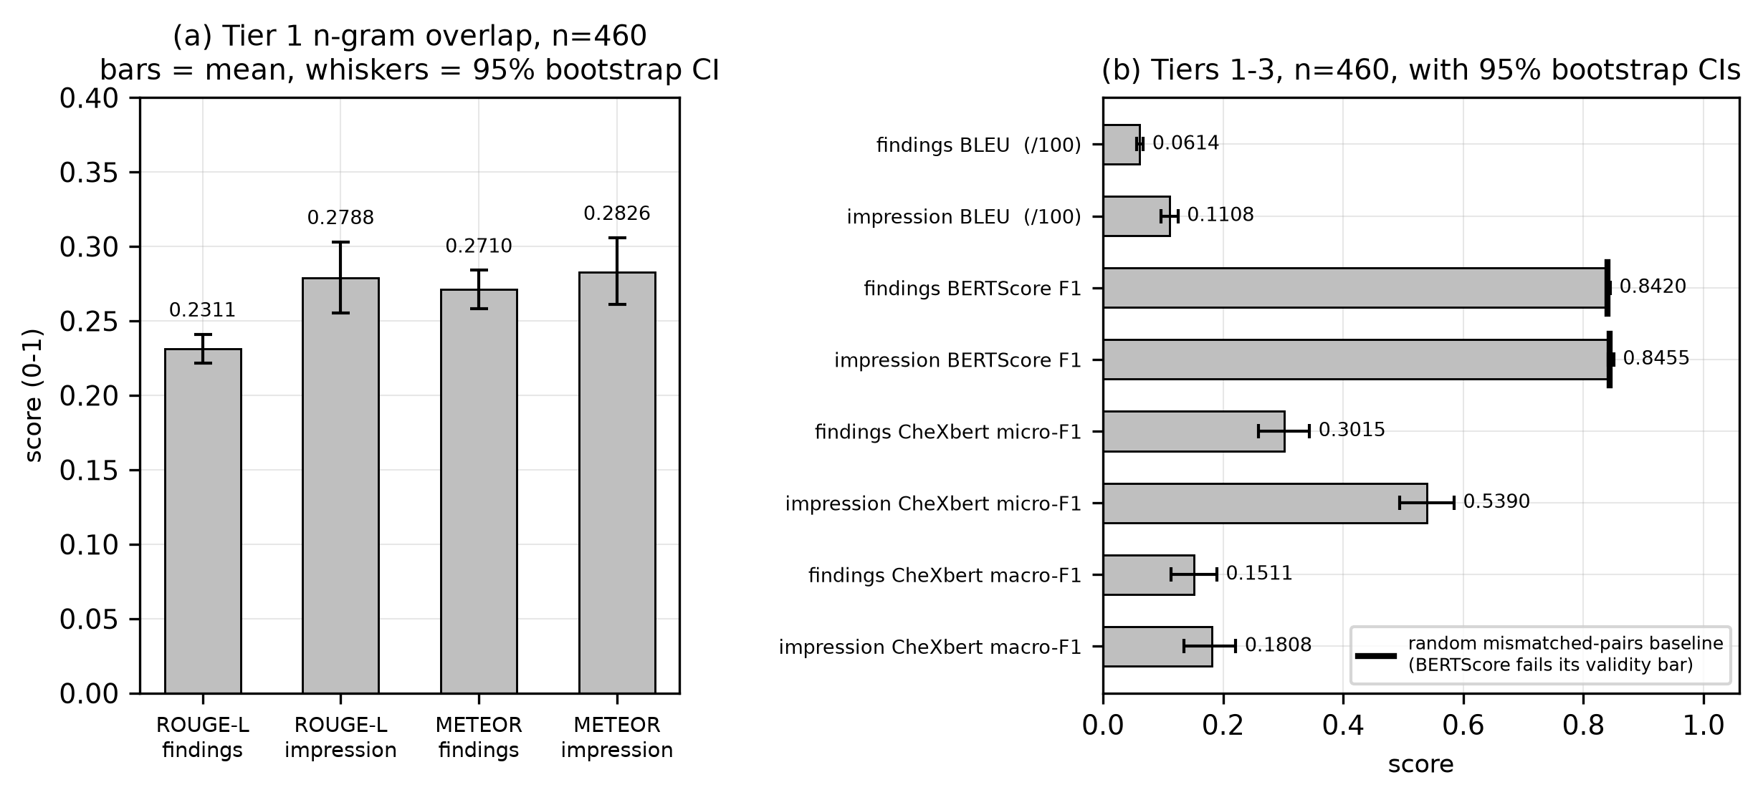
Figure 6.2: Phase 20 generation quality, Tiers 1–3, with 95% bootstrap confidence intervals — including the BERTScore random-baseline line that Tier 2 fails to clear.
Source: thesis final report/04_figures/fig02_phase20_generation_quality.png, built from tier1/tier2 bootstrap summaries, the random baseline file and tier3_chexbert_summary.json.

6.3.1 Tier 1 — n-gram overlap
Table 6.5: Phase 20 Tier 1: n-gram overlap against reference text. n = 460.
Source: ml/outputs/evaluation/generation/tier1_bootstrap_summary.csv.
Metric | n | Mean | 95% CI
findings BLEU | 460 | 6.137 | [5.615, 6.711]
findings ROUGE-L | 460 | 0.2311 | [0.2215, 0.2409]
findings METEOR | 460 | 0.2710 | [0.2583, 0.2839]
impression BLEU | 460 | 11.083 | [9.692, 12.493]
impression ROUGE-L | 460 | 0.2788 | [0.2552, 0.3030]
impression METEOR | 460 | 0.2826 | [0.2612, 0.3058]
These intervals are tight and the numbers are usable, but what they measure must not be overstated: n-gram overlap records lexical resemblance to a reference report, not clinical correctness. Two reports can share few words and mean the same thing, or share many and differ on the one finding that matters.

6.3.2 Tier 2 — BERTScore fails its own validity check
This is a metric-validity finding, and it is reported as a result rather than as a missing row.
Table 6.6: Phase 20 Tier 2: BERTScore against a random mismatched-pairs baseline. n = 460.
Source: tier2_bootstrap_summary.csv and tier2_bertscore_random_baseline.csv. Model: PubMedBERT, layer 9.
Section | F1 | 95% CI | Random mismatched-pairs baseline
findings | 0.8420 | [0.8394, 0.8447] | 0.8403
impression | 0.8455 | [0.8406, 0.8505] | 0.8432
A metric that scores randomly paired reports almost as highly as genuinely matched ones is not discriminating on this corpus. The validity bar was pre-registered, the tier failed it, and Tier 2 must not be reported as a quality result — here or anywhere. The finding is not that this system scores 0.84; it is that 0.84 means nothing here, because so does a random pairing. Having established this on Arm C, the same conclusion was re-checked in Phase 21 and stood, which is why BERTScore is absent from every later contrast. That exclusion predates the results it would otherwise have applied to, so it is not result-shopping.

6.3.3 Tier 3 — clinical labels, the valid instrument
Table 6.7: Phase 20 Tier 3: CheXbert clinical-label agreement. n = 460.
Source: ml/outputs/evaluation/generation/tier3_chexbert_summary.json.
Section | micro-F1 | macro-F1
findings | 0.3015 | 0.1511
impression | 0.5390 | 0.1808
findings, real − random baseline (macro-F1) | +0.0767 — excludes zero
Tier 3 clears the bar Tier 2 missed: the system’s findings agree with the reference labels significantly better than a random baseline does. The absolute values are nonetheless low, and this report does not dress them up. A macro-F1 of 0.1511 on findings is a weak clinical signal, and §6.12 states that plainly as a limitation.

6.3.4 The 17 structural failures — one root cause
All 17 failures trace to a single cause: the model inconsistently quoting label names inside the disclaimer field’s JSON string value, which broke parsing at that boundary. The response was not to patch the parser but to change the output format from JSON to delimiter markers, removing the nested-string boundary a stray quote can break — for that field and every other. 1,777 generations since have produced zero structural failures.
One qualification applies to that zero and to every other in this chapter: it means zero failed after retries, never zero needed a retry, because the attempt count is not recorded (§5.3.7).

6.3.5 The Fracture attribution failure, and what it revealed
This is the most consequential finding of Phase 20, and it was discovered by refusing to dismiss an anomaly as noise. In the per-label breakdown, Fracture had 18 reference-positive and 18 generated-positive cases — balanced, non-trivial support on both sides — and the two sets of 18 study identifiers were completely disjoint. An investigation followed, in the order most consequential for the project’s core claim.
- The headline — a grounding-attribution failure. For all 18 generated-positive cases, the real backend session behind each generation was located by exact text match and its real retrieved evidence rows were cross-referenced against the retrieved studies’ own report text. In 18 of 18, at least one fracture-mentioning study was present in the real top-5 retrieved evidence. This is not hallucination from nothing — it is worse in an important sense: the fracture belongs to a retrieved neighbour, not to the query patient, whose own reference report contains no fracture in any of the 18 cases. The offending neighbour is not reliably the top-ranked one either, appearing at rank 1 in some cases and rank 4 or 5 in others, meaning the system will incorporate an incidental finding from any retrieved neighbour, not only its closest match.
- A related recall gap. For the 18 reference-positive cases, the generated findings text was read directly: all 18 contain no fracture-related language whatsoever — not alternate phrasing the labeller missed, but complete absence. When retrieval happens not to surface a fracture-positive neighbour, the system has no basis to generate the finding.
- A minor, separately confirmed labeller bug. Re-reading the 18 reference texts found that 5 of the 18 are negations the labeller mislabelled as positive: three contain the identical phrase “No acute, displaced rib fractures” and two a close variant. This accounts for 5 of the 18, not the majority, and does not touch the generated-positive side at all.
What this revealed is the finding that redirected the project. Unlike the BLEU and BERTScore findings, this is a statement about the system, not about which metric can measure it. Image retrieval similarity does not guarantee that an incidental finding is specific to the query patient, and nothing in the generation step verified that a finding present in retrieved evidence belonged to the case being reported on before stating it as fact. Phase 22 is that mechanism measured at corpus scale.

6.4 Evidence-Mode Ablation (Phase 21)
Phase 21 asked whether full retrieved evidence produces better reports than voted labels alone, or than no retrieval-derived evidence at all. Three arms differed only in what the context builder assembles, switched by a configuration value rather than a code path.
Table 6.8: The three arms. Arm C is the v1.1 production configuration.
Source: 06_results/phase21_ablation.md; docs/methodology/phase21_ablation_architecture.md.
Arm | Evidence text | Voted labels | Disclaimer | Mode
A | ✗ | ✗ | ✓ | empty
B | ✗ | ✓ | ✓ | labels_only
C | ✓ | ✓ | ✓ | full
Arm B must never be described as “no retrieval”. Retrieval still executes in arm B; only its output is reduced to voted labels. The accurate description is retrieval-as-classifier, and it matters because arm B is the modern equivalent of the classify-then-template approach this project abandoned after Phase 0. C−B is therefore the direct empirical test of the retrieval-augmented design against a classification-based one. Even in arm A, retrieval still runs to create the session; only its output is discarded before context assembly.
Run integrity was complete: 100 attempted and 100 completed in every arm, 100 shared by all three, zero retrieval mismatches. At n=477, arms C and B both completed 477 of 477.
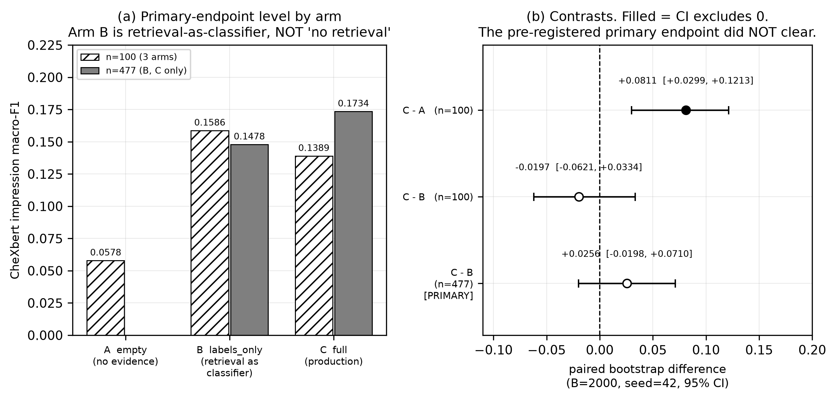
Figure 6.3: Phase 21 arms A/B/C on the primary endpoint and the three contrasts. The pre-registered C−B primary endpoint is hollow — its interval includes zero — at both sample sizes. The n=100 and n=477 bars are different case sets and are not comparable row-wise.
Source: thesis final report/04_figures/fig03_phase21_arms_primary.png, built from phase21_arm_contrasts.json and phase21_arm_contrasts_n477.json.

6.4.1 The primary endpoint did not clear
The endpoint was fixed in advance: clinical-label macro-F1 on the impression, arm C minus arm B, paired bootstrap, interval excluding zero in the positive direction.
Table 6.9: The pre-registered primary endpoint, at both sample sizes.
Source: ml/outputs/evaluation/phase21_arm_contrasts.json and phase21_arm_contrasts_n477.json.
n | Estimate | 95% CI | Excludes 0 | Verdict
100 | −0.0197 | [−0.0621, +0.0334] | no | did not clear
477 | +0.0256 | [−0.0198, +0.0710] | no | DID NOT CLEAR
The n=100 interval was 0.0955 wide and contained zero, values favouring B and values favouring C — it could not distinguish no effect from an effect this design could not resolve. The endpoint was extended to all 477 eligible cases by a rule fixed in advance, and by the same precedent as Phase 20’s extension. It still did not clear.
This is reported as a negative result, in full. No alternative metric, field or contrast was promoted to primary afterwards — the pre-registration forbade it in advance, and the ban was honoured.

6.4.2 The secondary contrasts, which all cleared
Table 6.10: Secondary C−B contrasts at n=477. Exploratory: a family, not independent confirmations.
Source: ml/outputs/evaluation/phase21_arm_contrasts_n477.json.
Metric | Estimate | 95% CI | Excludes 0
findings ROUGE-L | +0.0919 | [+0.0832, +0.1012] | yes
findings METEOR | +0.2265 | [+0.2151, +0.2376] | yes
findings CheXbert macro-F1 | +0.0587 | [+0.0165, +0.0978] | yes
impression ROUGE-L | +0.2145 | [+0.1906, +0.2403] | yes
impression METEOR | +0.2097 | [+0.1858, +0.2348] | yes
impression CheXbert macro-F1 (PRIMARY) | +0.0256 | [−0.0198, +0.0710] | no

6.4.3 The recall-driven decomposition and the length confound
Three properties of these numbers bound what may be concluded from them, and all three are stated because two of them cut against the adopted design.
The arm levels reveal a metric artefact, not a quality ordering. Arms B and A score higher micro-F1 than arm C while scoring far lower macro-F1 — at n=477, arm B reaches 0.6002 impression micro-F1 against arm C’s 0.5250, while arm C leads on macro-F1. The micro figure is dominated by the No Finding class. This is the phase’s first methodological finding: micro-F1 is unusable as a between-arm metric on this dataset, and it is precisely why the pre-registered endpoint was macro-averaged.
The length confound is real and is why the large secondary gains must be read carefully. The n-gram contrasts — METEOR at +0.2265 and +0.2097 — are very large, and arms differing in how much evidence text they receive also differ in how much they write. An n-gram metric rewards text that resembles a reference in surface form, and a longer, more clinically specific report will tend to score higher on it for reasons partly independent of correctness.
The one gain that length cannot explain is the clinical-label gain on findings: +0.0587 macro-F1, interval excluding zero. A clinical-label score does not reward text volume — it compares extracted finding sets, so writing more without being more correct does not raise it. This is the strongest evidence in the phase that full evidence does something beyond making reports longer, and it is on findings rather than on the impression that was pre-registered.
Arm A produced a degeneracy observation worth recording: it emitted one byte-identical string across all 100 cases. With no retrieval-derived evidence at all, the model has nothing case-specific to condition on and collapses to a single generic output. Arm A is additionally not a clean evidence contrast — with no labels available the prompt builder emits a different fallback sentence, so arm A’s prompt differs from arm C’s outside the evidence block as well as inside it. That fallback was deliberately not changed, because special-casing it would mean the ablation no longer measured the shipped system. This was named before any run, and C−A is reported at n=100 only, never on the same case set as the extended C−B.

6.4.4 What a null means, and what it does not
The symmetric reading is the honest one. The primary endpoint’s interval includes zero, so this phase did not demonstrate that full evidence improves impression-level clinical accuracy over retrieval-as-classifier. It equally did not demonstrate the opposite: the interval also contains substantial positive values, so a real effect this design could not resolve at n=477 is entirely consistent with the data. Section 6.9 explains why extending the sample further was not a route around this.
What the phase establishes, at the strength the evidence supports: full retrieved evidence beats retrieval-as-classifier on every n-gram metric and on findings-level clinical labels, with intervals excluding zero; on the one endpoint pre-registered as primary, the difference is positive but not distinguishable from zero at n=477. The design is supported on secondary evidence and unproven on its own primary endpoint, and this report says exactly that.
One deliverable of this phase was not produced, and it is recorded rather than omitted: the architecture specified a per-stage P50/P95 latency profile written to a named file. That directory does not exist and no such file exists anywhere in the repository. The stage-by-stage breakdown on which a resource-constrained deployment argument would ideally rest was never produced (§3.3.1).

6.5 Grounding Failure and Remediation (Phase 22)

6.5.1 The defect, as it was found
A live report contradicted itself. Its findings stated that the cardiomediastinal silhouette was unremarkable; its impression stated “Stable cardiomegaly with right mediastinal shift.” Investigation established three things about that single report. The impression was another patient’s impression, reproduced almost word for word from the top retrieved neighbour — that neighbour’s stored impression reads “1. Stable cardiomegaly with right mediastinal shift. 2. Stable interstitial markings and prominent bibasilar airspace opacities which [REDACTED] represent atelectasis”, and the generated text was that sentence pair with the numbering removed. The word “stable” referred to a prior study the patient did not have. And a fourth defect was present: a nodule placed in the right upper lung in findings became a right perihilar nodule in the recommendation — traceable to a different neighbour, rank 4. The report drew from at least two other patients’ reports.

6.5.2 Measured prevalence in v1.1
Table 6.11: Phase 22 diagnosis: prevalence of the three defects in v1.1, arm C, n=477.
Source: docs/phase22/diagnosis.md, via 06_results/phase22_diagnosis.md. The Phase 20 column is a separate-run observation and must never be differenced against arm C.
Measure | v1.1 arm C (n=477) | Phase 20 (n=460) | Note
Impressions with 5-gram overlap ratio 1.0 against a retrieved neighbour | 83 / 353 = 23.5% | not computable | Denominator is impressions of ≥ 5 tokens; 124 were shorter. Longest contiguous copied run: 42 tokens.
Reports using ≥ 1 of five temporal terms with no prior study | 167 / 477 = 35.0% | 97 / 460 = 21.1% | Every case in both harnesses had no prior study.
Strict internal contradiction (findings vs impression) | 22 / 477 = 4.6% | 9 / 460 = 2.0% | The loose asymmetry rate is 300/477 = 62.9% and is not a contradiction rate.
Of the copied impressions, those carrying a positive finding (harmful) | 22 / 83 = 26.5% | — | Harmful transplant rate against all scorable: 22/353 = 6.2%.
Transplant rate is not computable for Phase 20 at all — its per-case results carry no retrieved-identifier column and the neighbour identities for those 460 generations were never persisted. No substitute number is offered.
Two caveats bound how hard these numbers can be pushed. Temporal counts are lexical, from word-boundary regular expressions rather than adjudicated readings — “stable” has a non-temporal clinical sense — and a 20-case audit at a stated seed put matcher precision at 95%. And contradiction counts are labeller output, subject to the confirmed negation bug; ten of the 22 cases were read individually and are genuine, twelve were not.

6.5.3 The four root causes
Table 6.12: The four confirmed root causes. RC1–RC3 are independently sufficient; RC4 explains why none was caught.
Source: docs/phase22/diagnosis.md §3, each traced to file and line.
# | Root cause | Evidence
RC1 | No section-to-section grounding. One model call emits all seven fields as siblings of the evidence block; the impression is never conditioned on this report’s findings. Section regeneration was worse — it omitted the report’s own content and instructed the model not to consider other sections. | 22/477 strict contradictions; 10 of 11 Cardiomegaly cases in the findings-negative / impression-positive direction.
RC2 | Neighbour text is rendered verbatim with no attribution boundary and no anti-copying instruction. The only grounding rule forbade invention, and thereby rewarded copying. | 83/353 = 23.5% at overlap ratio 1.0; longest run 42 tokens.
RC3 | No prior-study state exists in the generation context, and no temporal restriction was applied. The prohibition existed only in the comparison path — that is, only where a prior study does exist. | 167/477 = 35.0%.
RC4 | The one semantic check could not represent this failure class, and gated nothing. It concatenates sections before inspection, so cross-section contradiction is unrepresentable; its unsupported-terms check flags only terms absent from evidence, so a transplanted finding is structurally exempt; it has no temporal check; and its result is never branched on. | —
RC2 and RC3 compound: a copied span imports its own temporal language. And RC2 is the same mechanism the Phase 20 Fracture investigation identified in 18 of 18 cases, now measured at corpus scale on the impression field rather than inferred from one label’s anomaly.
One methodological property of this diagnosis is worth recording: no fix was chosen and no fix code was written during it. Candidates were enumerated only, so that the fix could not be selected on knowledge of which would score best.

6.5.4 The fix
v1.2 changes the prompt in four ways and adds one service. (i) The evidence block is headed EVIDENCE — OTHER PATIENTS’ REPORTS (reference only), stating that the text is not this patient’s history and prohibiting the reproduction of sentences or the transfer of findings, measurements, laterality or devices. (ii) New section-support instructions: findings first; the impression a synthesis of this report’s findings; the recommendation preserving the findings’ location and laterality. (iii) A prior-study block stating that no prior exists and naming the forbidden temporal terms, sourced from the same configuration value the checker matches on. (iv) Section regeneration receives the report’s current findings.
Alongside these, a consistency service runs three checks — temporal, transplant and contradiction — and records what it found without altering anything the model wrote. That the service is observational is asserted by test: the same fake model output, generated with and without the service injected, produces byte-identical persisted content.
The prompt grew by exactly +338 tokens on every one of the 477 cases, peaking at 1,574 of 4,096 — so nothing is truncated.

6.5.5 Gate A: the pre-registered evaluation
477 cases were driven through the real API path, paired per study identifier against the stored v1.1 outputs, with both arms labelled by the same frozen instrument. Configuration parity with the earlier phase was verified live before generation. 477 of 477 completed, 0 failed.
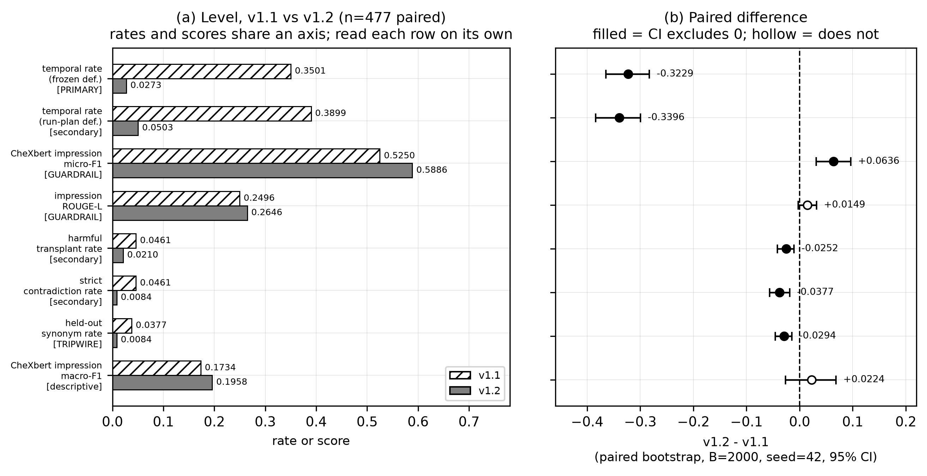
Figure 6.4: Phase 22 Gate A: every endpoint, v1.1 against v1.2, with paired confidence intervals. Rates and scores share one axis — each row must be read on its own, and the bars are not comparable across rows. The impression ROUGE-L guardrail marker is hollow.
Source: thesis final report/04_figures/fig04_phase22_gateA_endpoints.png, built from gate_a_endpoints.json and gate_a_results.md §3.1.1.
Table 6.13: Gate A: the three gating criteria. Paired, n=477.
Source: docs/phase22/gate_a_results.md §3.
Criterion | v1.1 | v1.2 | Diff | 95% CI | Verdict
1. Primary — temporal-term rate (frozen definition) | 0.3501 (167/477) | 0.0273 (13/477) | −0.3229 | [−0.3648, −0.2830] | PASS
secondary definition (9 terms, + recommendation) | 0.3899 (186/477) | 0.0503 (24/477) | −0.3396 | [−0.3836, −0.2998] | consistent
2. Clinical guardrail — impression micro-F1 (δ = 0.05) | 0.5250 | 0.5886 | +0.0636 | [+0.0314, +0.0961] | PASS
3. Supplementary guardrail — impression ROUGE-L (δ = 0.03) | 0.2496 | 0.2646 | +0.0149 | [−0.0024, +0.0317] | PASS
Two readings must be got right. The clinical guardrail was a non-inferiority bound, and the measurement is an improvement — but it is reported as clearing the bound, which is what was pre-registered. The supplementary guardrail’s interval includes zero, so it is not evidence of improvement; it shows only that textual drift is bounded well inside the margin, which is all that guardrail was for.
Table 6.14: Gate A secondary and descriptive endpoints. These do not gate.
Source: docs/phase22/gate_a_results.md §3.4.
Endpoint | v1.1 | v1.2 | Diff | 95% CI | Excludes 0
harmful transplant rate (strict) | 0.0461 (22/477) | 0.0210 (10/477) | −0.0252 | [−0.0419, −0.0105] | yes
strict contradiction rate | 0.0461 (22/477) | 0.0084 (4/477) | −0.0377 | [−0.0566, −0.0189] | yes
held-out synonym rate (tripwire) | 0.0377 (18/477) | 0.0084 (4/477) | −0.0294 | [−0.0461, −0.0147] | yes
impression macro-F1 | 0.1734 | 0.1958 | +0.0224 | [−0.0266, +0.0683] | no
The held-out tripwire did not fire, and this is the most important negative control in the project. Ten temporal synonyms were generated from the frozen document and never shown to the model, with a test asserting their absence from every prompt the backend can send. If the fix had merely taught the model to avoid five specific words, the held-out rate would have held steady or risen while the primary rate collapsed. Both fell. Under the reading rule fixed in advance, that is consistent with a real change in behaviour rather than word-avoidance.
The noise floor is the second control, and it is what makes the primary result defensible. The previous version was checked out in a separate worktree, served against a byte-verified copy of the same collection, and re-run on 100 pilot cases with identical settings. 67 of 100 outputs were not byte-identical — generation is materially non-deterministic — yet the primary endpoint’s own measurement moved 0.0 percentage points, 46/100 before and 46/100 after. The text varies while the endpoint is stable, so the −32-percentage-point primary result cannot be attributed to re-run noise.
Generation and consistency outcomes: 477/477 completed, 0 structural failures; consistency status partial 459, violations 17, clean 0, not_run 0. No report reads clean, exactly as the amendment predicts before Gate B. The retry count is 0 for every case, by construction.

6.5.6 The verdict, and why adoption is not final
Applied mechanically: criterion 1 PASS under both definitions; criterion 2 PASS at +0.0314; criterion 3 PASS at −0.0024. Adopt v1.2 on the three gating criteria: yes.
But adoption is not final, and every sentence in this report that mentions v1.2 carries that qualification. Two withhold triggers were pre-registered. The first — the held-out rate failing to fall while the primary collapses — did not fire. The second — a single clear grounding failure in the blinded manual read — remains open: the packet was built (40 reports, no version information, answer key held separately) and 0 of 2 readers have submitted. That trigger is a stop condition that overrides a clean pass on all three criteria. The correct statement of Gate A’s verdict is therefore “passes every automated criterion”, not “cleared for adoption”.
A real pre-registration defect is recorded rather than resolved quietly. The frozen document supported two incompatible readings of its own primary endpoint: one section named three report sections and a nine-term list, while its stated baseline figure had been computed over five terms and two sections. The run plan followed the wider definition without noticing that the quoted baseline came from the narrower one. The more conservative frozen definition is reported as primary, and the verdict is identical under both. The defect is disclosed because a pre-registration that is quietly reinterpreted after the fact provides none of the protection it exists to provide.

6.5.7 Post-hoc analysis: is the improvement just shorter text?
Nothing in this subsection was pre-registered. No number here is a criterion and the Gate A verdict is not revisited. These analyses are reported because several change how the results above should be read — in one case decisively, and in two cases against the fix.
The shortening is real. Findings word count fell from a median of 48 to 30 (−38%), and impressions from 9 to 5, with the long tail compressed from a maximum of 181 to 109. The obvious alternative explanation for every Gate A result is therefore that the system simply writes less. Four independent tests refute it.
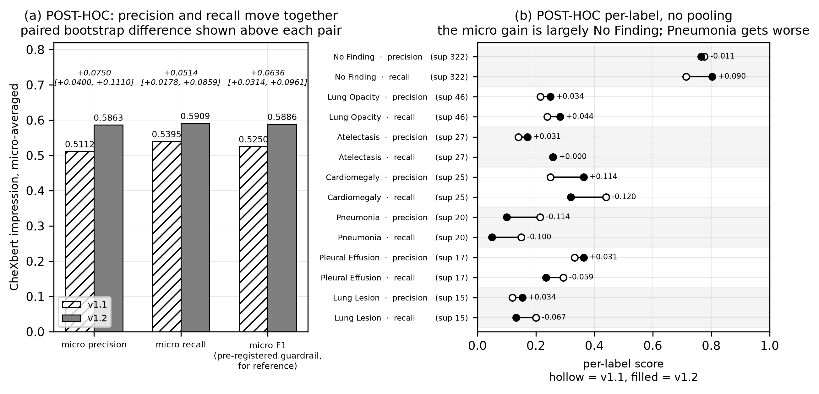
Figure 6.5: Phase 22 post-hoc micro precision and recall, and per-label detail with supports. Everything in this figure is post-hoc, not pre-registered. Seven of the fourteen labels have support below 10 and are omitted from the per-label panel as unreliable.
Source: thesis final report/04_figures/fig05_phase22_posthoc_micro_pr.png, built from the post-hoc output reproduced in gate_a_results.md §6.
- Precision and recall separately — the decisive test. Micro precision rose from 0.5112 to 0.5863, +0.0750 [+0.0400, +0.1110], and micro recall from 0.5395 to 0.5909, +0.0514 [+0.0178, +0.0859]. Both rose and both intervals exclude zero. If shortening were the mechanism, precision would rise (fewer assertions, fewer false positives) while recall fell (fewer assertions, fewer true positives caught). Recall rose instead. The system writes less and catches more of what the reference says. That is not what truncation looks like.
- It does not fall silent on real findings. Cases where the generated impression carries no positive label while the reference impression carries at least one: 56/477 in both versions — identical. v1.2’s impressions are empty of positive labels more often overall (338 → 365), but the extra silence falls entirely on cases where the reference is also negative.
- The temporal reduction is far larger than the length reduction. Restricted to findings alone, the temporal rate fell from 0.2872 (137/477) to 0.0126 (6/477), −0.2746 [−0.3145, −0.2348]. Findings length fell 38%; the findings temporal rate fell 96%. A 38% length cut cannot produce a 96% reduction unless temporal language were concentrated in exactly the removed text.
- The transplant improvement survives its denominator confound. The scorable denominator fell from 353 to 280 because v1.2 impressions are shorter, so part of the headline improvement might have been unscorability rather than less copying. Restricting to the 261 cases scorable in both arms removes the confound: 0.0805 (21/261) → 0.0383 (10/261), −0.0421 [−0.0728, −0.0153]. Harmful transplantation roughly halves on identical cases. The denominator shift inflated the headline figure but did not create it.

6.5.8 Two post-hoc findings that argue against the fix
A report presenting only the four results above would be reporting half of this analysis. Two findings cut the other way.
The micro-F1 gain is substantially a No Finding gain, and one real condition got worse. Per-label figures show No Finding — support 322, by far the largest — improving in recall from 0.714 to 0.804 and carrying the aggregate. Pneumonia is clearly worse: recall fell from 0.150 to 0.050 on a support of 20, with precision falling from 0.214 to 0.100. Cardiomegaly trades recall for precision. Seven of fourteen labels have support below 10 and their figures should not be read as estimates of anything. The per-label picture is not uniformly favourable, and this report does not present it as one.
A residual defect survives in the opposite direction to the one fixed. The v1.2 constraint forbids the impression asserting what the findings did not state; it says nothing about the reverse — an impression omitting what the findings did state — and that failure mode persists. In 27 of 477 reports (5.7%), the generated findings carry at least one positive condition while the generated impression carries none. This is threefold better than v1.1’s 90/477, unprompted, but 27 cases remain and they are a genuine internal inconsistency. Five were sampled at a stated seed and three of five are genuine omissions:
uid 951 Findings: "...Mild right basilar atelectasis and relative elevation
of the right hemidiaphragm are noted..."
Impression: "The chest X-ray is normal, with no evidence of active
cardiopulmonary disease."

uid 3461 Findings: "The lung opacities are seen throughout the lungs, with
more focal streaky bibasilar opacities..."
Impression: "No acute cardiopulmonary abnormality" <- worst case
The remaining two are arguably labeller artefacts, the positive label being a support device rather than a pathology, on a reference support of 2. This defect is covered by no check in v1.2 and measured by no endpoint. It is measured against the report’s own findings, not against the reference — the analysis above shows v1.2 does not miss reference findings more often — so it is self-inconsistency, not under-detection. Section 6.12 carries it as a limitation and §8.3 as future work.

6.5.9 The trigger case, re-tested
The report that started Phase 22 was re-run against v1.2 three times. Retrieval reproduced exactly — all five neighbours and all five similarities identical to those stored with the original, in the same rank order, on every run — so any difference in the generated text is attributable to the prompt and not to different evidence.
Table 6.15: The trigger case re-tested. n = 1 case, 3 runs, qualitative. This proves nothing about rates.
Source: 01_facts/trigger_case_retest.md. For rates, see Gate A at n=477.
Defect | v1.1 | v1.2 (3 runs)
Self-contradiction (Cardiomegaly) | present | absent 3/3
Transplant from neighbour #1 | overlap ratio 0.50, longest run 9 tokens | ratio 0.00 in 3/3, longest run 2 tokens
“Stable” with no prior study | 2 occurrences | 0 occurrences in 3/3
Nodule location mismatch | present | does not arise 3/3 — the nodule is omitted, not relocated
The last row is recorded carefully rather than claimed as a fix. The mismatch cannot arise in v1.2 because no nodule is mentioned at all. Without ground truth for this image — the uploaded file matches no dataset study by hash — there is no way to say whether omitting the nodule is correct or is the loss of a real finding. This is the same omission-direction behaviour measured at 27/477 above.

6.6 Accuracy Improvement Experiment (Phase 23)
Phase 23 asked whether a larger model or an explicit label checklist improves v1.2’s labelled accuracy. Four variants × 150 development cases = 600 generations. The development set was drawn from the validation split, never the test pool, and four independent checks confirmed zero intersection with the test pool or the knowledge base. The selection rule was fixed in the plan before any variant ran and applied mechanically by a script.
Table 6.16: Phase 23: the four variants. n = 150 each; all completed, zero structural failures.
Source: docs/phase23/dev_results.md, via 06_results/phase23_accuracy.md.
Variant | Model | Checklist | Completed | Mean s | p95 | Max
V0 (incumbent) | llama3:8b | off | 150/150 | 4.56 | 4.97 | 7.15
V1 | qwen2.5:14b | off | 150/150 | 7.37 | 8.76 | 10.76
V2 | llama3:8b | on | 150/150 | 4.58 | 4.98 | 7.76
V3 | qwen2.5:14b | on | 150/150 | 7.33 | 8.36 | 10.79
Table 6.17: Phase 23 clinical-label results. V0 leads on 23 of 24 cells.
Source: ml/outputs/evaluation/phase23_dev_{V0,V1,V2,V3}/, frozen evaluation path.
 | Impression macro-F1 | Impression micro-F1 | Findings macro-F1 | Findings micro-F1
V0 | 0.1227 | 0.6120 | 0.1032 | 0.3513
V1 | 0.0826 | 0.5325 | 0.0928 | 0.3271
V2 | 0.1160 | 0.5833 | 0.0980 | 0.3404
V3 | 0.0788 | 0.5017 | 0.0902 | 0.3123
The single exception in 24 cells is findings macro-precision, where V2 leads V0 by 0.0008 — far inside noise, and on the section the checklist does not target.
Both larger-model arms reintroduced self-contradiction that neither incumbent arm produced (2/150 against 0/150). The counts are small and nothing here is powered to distinguish them, but the guardrail was pre-registered as a comparison against the incumbent’s rate rather than as a significance test, and was applied as written.
The verdict, exactly as the script printed it: V0 qualifies; V1 fails on precision drop and contradiction; V2 fails on temporal rate; V3 fails both. Qualifying variants that strictly beat V0: none. Winner: V0 — the incumbent. Step 3 was not run.
One honesty note is recorded with the result: the guardrails did not decide this. They are reported because the plan requires it, but they were not load-bearing — no variant beat V0 on the primary endpoint, so the verdict holds even if every guardrail is ignored. Stating it the other way round would overstate their role.

6.6.1 The support limitation, and why the checklist hypothesis is not refuted
This development set is genuinely underpowered for the question it was built to answer, and that is stated rather than minimised. 13 of the 14 clinical labels have reference support below 10 on these 150 cases, and 10 labels score 0.000 for every variant, contributing an identical constant to all four macro averages. The macro-F1 ranking is effectively decided by three labels.
This does not invalidate the verdict, for a specific reason: the ranking is identical under micro-averaging, which is not support-fragile in the same way, and identical on findings as well as on the impression. A conclusion holding only on macro-F1 would deserve much more scepticism.
But it does mean the checklist hypothesis is not refuted. A checklist targeting under-calling would be expected to help precisely on rare findings — which is exactly where this development set could not detect an improvement. The correct conclusion is “no benefit was detected on this dev set”, not “the checklist does not work”. The plan was deliberately not changed to accommodate this, the limitation having been discovered after the run; it is recorded as the first thing to fix if the experiment is repeated.
What the phase does establish is worth stating positively: a larger model is not automatically a better one for this task. The 14-billion-parameter model is 1.85× the parameters, costs 61% more latency and 4,276 MiB more VRAM, and is worse on every accuracy metric measured — while reintroducing a defect the smaller model did not produce. And a negative result arrived cheaply and without touching the test set, which is what the development-set design was for.

6.7 Analysis of Design Solutions
Table 6.18: Which design choices the evidence supports, and which it does not.
Source: This chapter.
Design choice | Evidence status
Retrieval instead of classification | Supported. DenseNet121 scored R@5 0.5127, below the random baseline’s 0.5155, while BiomedCLIP cleared Gate 1 on both metrics. The strongest evidence in the project for any design decision.
BiomedCLIP as the encoder | Supported, with one comparison open. Gate 1 passed cleanly and Gate 3 was satisfied; the Recall@5 comparison against generic CLIP remains inconclusive.
Full evidence rather than labels alone | Supported on secondary evidence; unproven on the pre-registered primary endpoint. The findings-level clinical gain (+0.0587, interval excluding zero) is the one gain length cannot explain.
The v1.2 attribution boundary | Supported, pending a blinded read. −32 percentage points on the primary endpoint, both guardrails clear, the held-out tripwire silent, and the noise floor showing 0.0 pp movement. The shortening explanation is refuted on four independent tests.
llama3:8b over a larger model | Supported. 23 of 24 cells, at 61% less latency and 4,276 MiB less VRAM.
The label checklist | Not supported — and not refuted. No benefit detected; the dev set was underpowered exactly where a benefit would appear.
Macro-averaged endpoints | Supported as a methodological choice. Phase 21 showed micro-F1 ranking arms in the opposite order to macro-F1, being dominated by No Finding.
Advisory rather than blocking semantic validation | Not evaluated. No experiment compared blocking against advisory. The choice rests on a design argument (§5.3.6), not on evidence.
The observational consistency service | Partially supported. Detection works and costs ~0.2% of request latency. Its value is unevaluated, because nothing acts on a violation: 17/477 were acted on by nothing.
PHI masking before embedding | Supported for safety, unvalidated for detection. Mean cosine 0.992 pre/post, 0 of 50 flagged. Detection recall is unmeasurable on this dataset.
Bilingual generation | Unevaluated. No Bengali output has ever been measured.
Browser print over server-side PDF | Supported for delivery, verified for Bengali. 9 sections, 781 codepoints, conjuncts correct, no missing glyphs.
The optimisation actually performed on the selected design was Phase 23, and its outcome is worth stating precisely: the selected design was tested against two plausible improvements and retained because neither improved it. That is an optimisation that returned a null, not an absence of optimisation.

6.8 Final Design Adjustments
Two adjustments were made in response to evaluation results, and they point in opposite directions — which is what makes them worth reporting together.
The v1.2 remediation is the substantive final adjustment. It was not planned: it exists because a defect was observed in this system’s own output, diagnosed to four root causes, measured at corpus scale, fixed, and then evaluated under criteria fixed before the fix was run. The adjustment is adopted in the shipped code and not finally adopted as an evaluated claim, because the blinded read that could override the pass has not been performed. Both halves of that sentence are true simultaneously, and the report states both wherever v1.2 appears.
The Phase 23 decision to change nothing is the other adjustment. Having a pre-registered selection rule produce the incumbent is a real outcome of a real experiment: two plausible improvements were tested at a cost of 600 generations and neither qualified. The configuration flag for the rejected checklist ships set to false, with the prompt byte-identical to the evaluated one — so the evaluated system and the shipped system are the same system.
A third, smaller adjustment belongs here because it followed the same discipline: the partial consistency status. Review found that a report where only some checks ran, and those found nothing, was reporting itself clean — overstating assurance. Implementing the fix exposed a larger instance: the transplant check was being counted as run while structurally unable to report anything. The consequence is that every English report now reads partial, which is correct rather than unfortunate: one of three checks genuinely is not operational, and the previous behaviour asserted a completeness the system does not have. A dashboard that looks worse after an amendment is a dashboard that has started telling the truth. Four stored rows written under the earlier rule still read clean and were recorded rather than migrated.

6.9 Statistical Analysis

6.9.1 Bootstrap configuration
2,000 resamples, seed 42, percentile method, paired per study identifier, throughout. Phase 0 additionally stratified by class. The configuration was carried forward rather than re-chosen per phase, so no phase selected a procedure after seeing its data.

6.9.2 Why the macro-F1 interval does not narrow with n
This is a genuine statistical finding of the project and it constrains everything above. Extending the Phase 21 endpoint from 100 to 477 cases — a 4.77× increase — reduced the macro-F1 confidence interval width by 5%, against the 2.2× narrowing that independent sampling would predict.
What follows from it is important. A macro average over a long-tailed label distribution is dominated by the labels with the least support, and adding cases adds very few instances of those labels. The interval is therefore not primarily an expression of case-level sampling noise that more cases would reduce; it is an expression of rare-label scarcity. Collecting more cases from the same distribution is not a route around the Phase 21 null. A better-powered version of that experiment needs a case set enriched for rare findings, not simply a larger one. A related caution is recorded: the n=100 and n=477 macro-F1 figures are not the same estimand, and the two are presented side by side rather than as a convergence.

6.9.3 Micro against macro, and gameability
Micro-F1 pools every label decision and is dominated here by No Finding at a support of 322 of 477. Macro-F1 averages per-label scores, giving a rare finding the same weight as a common one. Phase 21 showed these two rank the arms in opposite directions: arms B and A score higher micro-F1 than arm C while scoring far lower macro-F1. An arm that reports fewer findings scores better on micro-F1 on a dataset where most studies are normal. Micro-F1 is therefore gameable on this dataset and is unusable as a between-arm metric, which is why every pre-registered endpoint was macro-averaged — and why the Phase 22 micro-F1 guardrail improvement is read in §6.5.8 alongside its per-label decomposition rather than on its own.

6.9.4 Non-determinism at temperature 0, and the noise floor
Generation is materially non-deterministic at temperature 0.0 with seed 42. Re-running identical code against a byte-verified identical collection on 100 pilot cases produced 33 byte-identical outputs and 67 differing.
The cause was diagnosed by measurement rather than assumption, and it has two independent parts. Temperature 0 selects the highest-probability token but does not pin the sampler’s starting state: with no seed, five identical requests produced two distinct reports, diverging inside the impression. With a seed pinned, five runs were byte-identical — but the seed alone is not sufficient, because the first inference after the model loads differs reproducibly from every later one. Across three unload-and-reload cycles the cold and warm outputs were the same two values every time: each state is perfectly reproducible, and they are reproducibly different from each other. Generation is therefore deterministic conditional on whether the model was resident, which is precisely the reported symptom — draft a report, return later, upload the same image, receive different words with nothing having changed. A seed and a keep-alive were both added, each addressing one half. The residual cold/warm boundary is warm-up state in the inference runtime and nothing at this layer can remove it.
A related historical fact is recorded because it bears on every generation this system has produced: for most of the project only two generation parameters were ever configured — the model and the temperature. Sampling parameters and the seed were never set anywhere in the codebase and silently took the runtime’s own defaults, unrecorded. Temperature 0.0 was the only reproducibility lever this system ever pulled, and it was not sufficient on its own.
The noise floor is what makes the Phase 22 result interpretable despite all this. The measured endpoint moved 0.0 percentage points across the re-run — 46/100 before, 46/100 after — while 67% of the text changed. Both halves matter: the text varies, so no claim in this report rests on exact output reproduction; the endpoint is stable, so the −32-percentage-point result cannot be attributed to re-run noise.

6.9.5 Structural failure rates across phases
Table 6.19: Structural failure rates in every phase that measured one. Never pooled — each states its own n.
Source: 06_results/performance_and_tests.md §6.
Phase | System | n | Structural failures
20 | v1.1 (JSON output) | 477 | 17 (3.6%) — all one root cause
21, all arms | v1.1 (delimiters) | 100 × 3 | 0
22 Gate A | v1.2 | 477 | 0
23, all variants | v1.2 | 150 × 4 | 0
Every zero above means zero failed after retries, not zero needed a retry (§5.3.7).

6.10 Comparisons and Relationships

6.10.1 Comparison with published work
The caveat comes before the comparison, because it governs it. A clinical-efficacy F1 reported by a published report-generation model and one reported here differ in at least four respects at once: the dataset (predominantly MIMIC-CXR against IU X-ray), the labeller configuration, the averaging convention (micro against macro), and the amount of training (hundreds of thousands of supervised examples against none). Four simultaneous differences do not produce a ranking, and any comparison of this kind is indicative only.
[TO CONFIRM: the specific CE precision, recall and F1 figures reported by R2Gen and its successor models, with the dataset and labeller configuration each used, must be read from the primary publications and inserted here. This project’s repository contains no bibliography file and no transcribed published figure, and reconstructing values from memory would violate the traceability rule this report is written under. No value is supplied from memory.]
The fair statement, and the only one this project’s evidence supports, is therefore a statement about feasibility under constraint rather than about competitive quality: this system reaches a clinical-label agreement range comparable to published work without performing any model training at all, on a dataset an order of magnitude smaller, running entirely on a single consumer GPU. Whether it is better or worse than any specific published system is a question this comparison cannot answer, and this report does not answer it.

6.10.2 Relationships between retrieval quality, evidence mode and report quality
Reading the phases together — as relationships rather than as pooled numbers — four statements hold.
- Retrieval quality bounds report quality, but does not determine it. Phase 0 established that BiomedCLIP retrieves clinically related cases better than chance or generic features. Phase 20 then established that good retrieval is not sufficient: in all 18 Fracture cases the retrieval was working, surfacing genuinely similar cases, and the failure was that the generation step had no mechanism to decide whether a retrieved finding belonged to this patient.
- More evidence in the prompt produces more clinically specific text, with a detectable but modest gain in clinical accuracy. Arm C beats retrieval-as-classifier on every n-gram metric and on findings-level labels, with the findings clinical gain being the one length cannot explain — while the impression-level clinical gain is not distinguishable from zero.
- More evidence also creates the attribution risk. Arm A, with no retrieval-derived evidence, cannot transplant a neighbour’s finding — it also collapses to one byte-identical string across 100 cases. The evidence that makes reports specific is the same evidence that can be copied; the fix was not less evidence but an explicit attribution boundary around it.
- Constraining the model improved accuracy rather than costing it. The intuition that tighter constraints trade accuracy for safety did not hold here: the clinical guardrail improved (+0.0636, interval excluding zero) alongside the −32-point reduction in ungrounded language, and post-hoc both precision and recall rose. The honest qualification is that the micro-F1 gain is substantially a No Finding gain and one real condition got worse.

6.11 Discussion

6.11.1 What the evidence supports
- That retrieval is the right architecture for this problem under these constraints. The classifier the proposal specified performs at or below chance on the retrieval task, and the retrieval design produces traceable evidence a classifier cannot.
- That a grounding defect in a generative clinical system can be found, diagnosed, fixed and measured — from an observation in one report, to four root causes, to corpus-scale prevalence, to a pre-registered evaluation showing a −32-percentage-point reduction on the primary endpoint with both guardrails clear.
- That the whole system runs on one consumer GPU at interactive latency: 7,125 MiB peak of 16,376, 4.50 s mean per report, with safety checking costing ~0.2% of the request.
- That privacy-preserving masking before embedding does not damage the representation: mean cosine 0.992 pre/post, 0 of 50 flagged.
- That pre-registration is practicable in a project of this size, and that it changes outcomes. It produced a null in Phase 21, a discarded metric in Phase 20, an incumbent winner in Phase 23, and a disclosed defect in its own protocol in Phase 22.

6.11.2 What the evidence does not support
- That full evidence improves impression-level clinical accuracy over retrieval-as-classifier. The pre-registered endpoint did not clear at either sample size.
- That the system is clinically accurate in absolute terms. Macro-F1 of 0.1511 on findings and 0.1808 on impression (Phase 20) are weak signals; the later phases improve on them but do not transform them.
- That v1.2 is adopted. It passes every automated criterion; the blinded read that could override that pass has not been performed.
- That the system is safe for clinical use. No clinician has evaluated any output, no regulatory process was entered, and 5.7% of reports carry a known internal inconsistency.
- That anything about the Bengali output is known. Nothing is.

6.11.3 What remains unknown
Three unknowns are structural rather than incidental, and each would require work this project did not do. Whether a clinician is faster or safer using this system is unknown, because none has used it — which makes every productivity and usability claim unevidenced, and is why §3.11.4 declines to give a cost–benefit figure. Whether the system performs on a Bangladeshi population is unknown, because every number here derives from one US-sourced corpus with a different disease prevalence. And whether the residual omission defect matters clinically is unknown: 27 of 477 reports state an abnormality and then call the study normal, and whether a reader catches that in practice is precisely the question a blinded read of the kind still pending would begin to answer.
One further unknown is worth naming because it is uncomfortable rather than technical. This project’s own instruments are imperfect in known ways — a labeller with a confirmed negation bug, a lexical temporal matcher at 95% precision, seven of fourteen labels below usable support — and every conclusion above is conditional on them. The appropriate response is the one taken throughout: state the instrument, state its known failure mode, and never claim precision the instrument cannot deliver.

6.12 Key Achievements and Limitations

6.12.1 Achievements, with their evidence
Table 6.20: Key achievements and the evidence for each.
Source: This chapter.
Achievement | Evidence
A complete, working, evidence-grounded reporting workspace | 26 API operations, 15 routes, 672 passing automated tests, an end-to-end flow exercised in a real browser.
An encoder choice made on pre-registered evidence, not assertion | Phase 0: Gate 1 passed on both metrics; Gate 3 satisfied on 11 of 15 classes (§6.2).
A grounding failure found in this system’s own output and remediated | 35.0% → 2.7% temporal; 4.6% → 0.8% contradiction; harmful transplant halved on a common denominator (§6.5).
Refutation of the obvious alternative explanation for that result | Four independent tests, including recall rising where truncation would lower it (§6.5.7).
Privacy-preserving masking that provably does not damage the representation | Mean cosine 0.992, 0/50 flagged (§4.4).
A design that runs on one consumer GPU | 7,125 MiB peak of 16,376; 4.50 s mean per report (§6.9, §3.3).
An evaluation discipline that survived its own negative results | A null primary endpoint reported as the headline; a metric discarded; an incumbent winner; a pre-registration defect disclosed.

6.12.2 Limitations
- Low absolute clinical accuracy. Macro-F1 of 0.1511 (findings) and 0.1808 (impression) in Phase 20. The system drafts usefully structured reports; it does not read radiographs accurately in absolute terms.
- The primary endpoint of the ablation did not clear. The central design claim — that full evidence beats labels alone on clinical accuracy — is unproven on the endpoint chosen to test it.
- English-only checking. All three consistency checks are English-only by construction. A Bengali report stores an empty checks-run list and reads not_run.
- Bengali is entirely unmeasured. Zero Bengali defect rates of any kind have ever been measured. Every harness generates English only. The bilingual feature is shipped and unevaluated, and no Bengali quality claim appears anywhere in this report.
- No clinician validation. No radiologist has evaluated any output or the interface. The blinded read is built and unperformed — 0 of 2 readers — and neither designated reader is a radiologist in any case.
- A single dataset from one institution in another country. Disease prevalence, reporting conventions and population differ from the intended deployment setting (§3.8.4).
- The omission defect remains: 27 of 477 reports (5.7%) state an abnormality in findings and call the study normal in the impression. No check covers it and no endpoint measures it.
- Detection without action. 17 of 477 recorded consistency violations were acted on by nothing; the clean state is unreachable because one check cannot emit a result. Gates B and C are unstarted.
- Features not implemented: licence verification, roles, server-side PDF, password reset, image explainability — each with its reason in §3.1.3.
- Instrument limitations bound every clinical number: a confirmed labeller negation bug, 7 of 14 labels below support 10, a lexical temporal matcher at 95% precision, and a discarded embedding metric.
- Non-determinism is characterised but not eliminated: 67 of 100 re-runs differ byte-for-byte.
- Reproducibility is qualified: no Python lockfile, an evaluation environment deliberately separate from production, and a documented case where persisted reproducibility metadata can reflect a later configuration than the one that ran.
This chapter has reported every evaluation this project performed, including the ones that returned nulls, the metric that failed its own validity check, the defect found in this system’s own output, and the remediation that has passed every automated criterion without yet being finally adopted. Chapter 7 is the user manual for the system as delivered.

